**Lab Exercise 2- Creating a Basic flow from Scratch using Power Automate - Reminder for overdue tasks!**

**In this Lab**

In this lab, you will create a cloud flow using a Power Automate template that will create an approval workflow when a SharePoint list item is created

* **Learning objectives-** Create a flow from scratch to run manually or on schedule
* **Duration** - 20 minutes
* **Scenario**- Send automated email reminders for overdue tasks in a SharePoint list
* **Prerequisites** - Each student must have a dedicated custom SharePoint list named **Work Progress Tracker**. The student will create this list in the first task of this lab.

**Task 1**

Create your own custom SharePoint list using the following steps:

* Navigate to your SharePoint site.
* Create a new list **Work progress tracker** available from Microsoft

a. Click on **Home** > **+ New** > **List** > **Work progress tracker** > **Use Template**

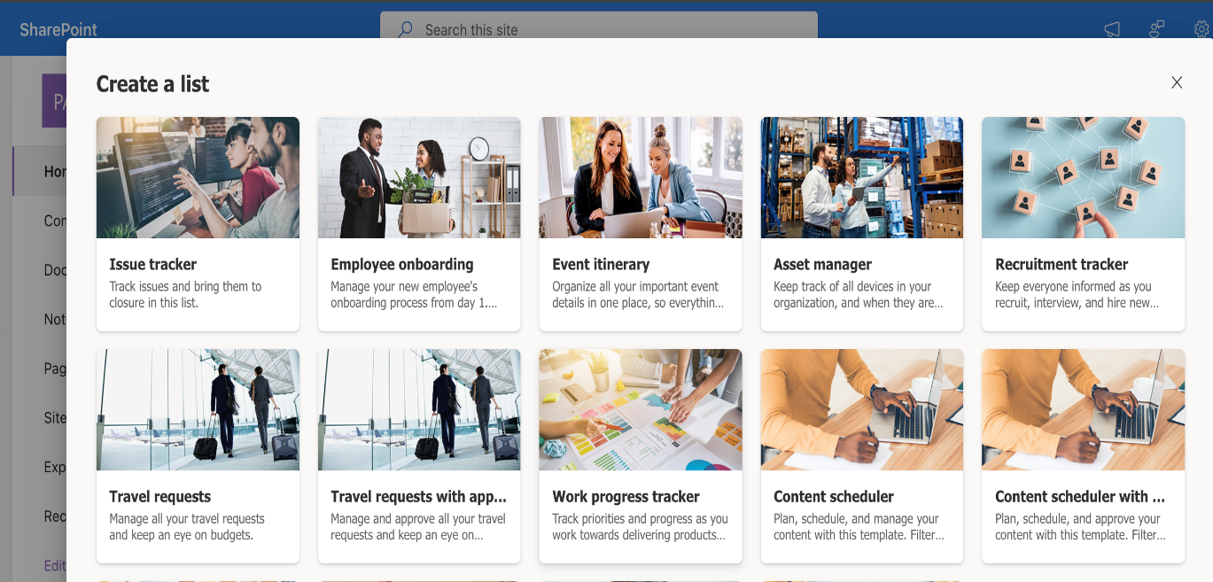

c. Populate this list with few items and assign to yourself

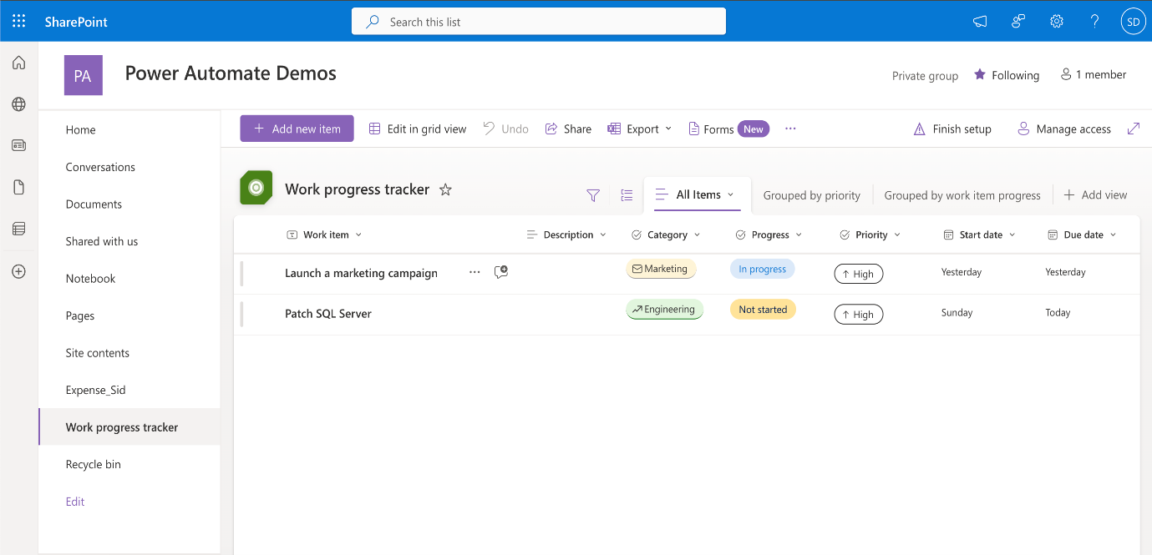

**Task 2**

Create a cloud flow from scratch:

a. Create a new Instant cloud flow and use a Manually trigger a flow as a trigger. Name it **Reminder for overdue tasks**. Click **Create**

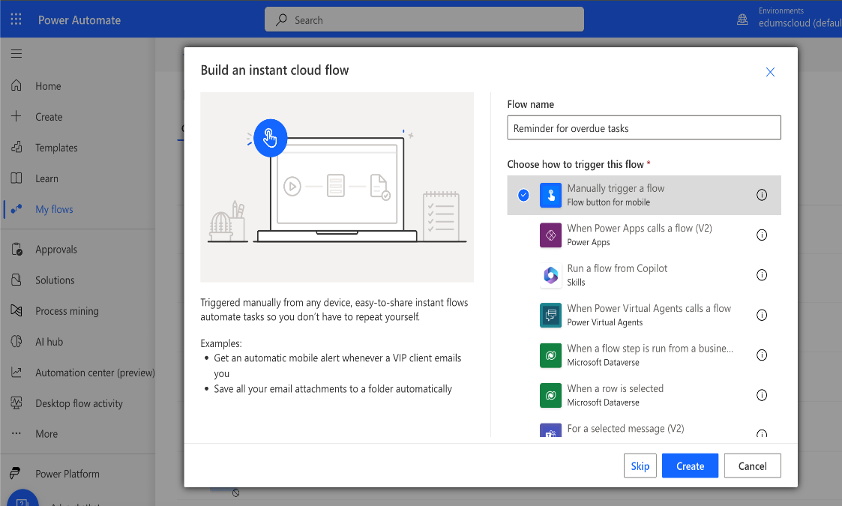

b. Add a new step to get all items from the SharePoint list **Work Progress Tracker**.

* Search for **Get Items** action
* Select the **Get Items** from the SharePoint list of actions
* Site Address: <SharePoint-Site URL>
* List Name: Work progress tracker

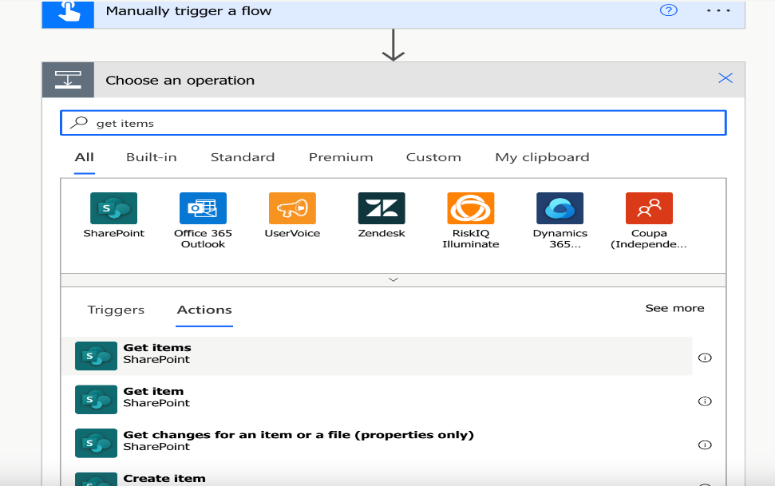

c. Add a new control connector and select **Apply to each** control

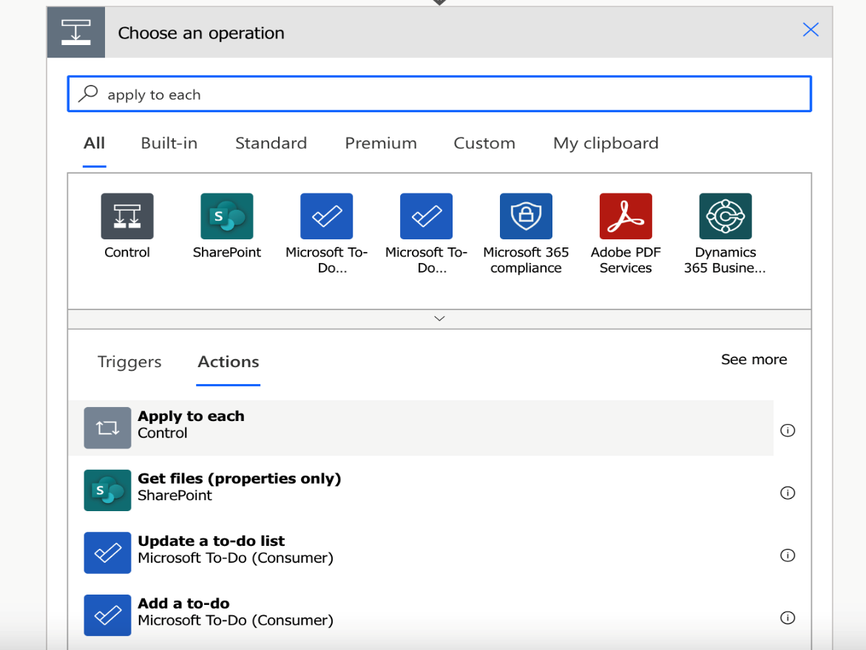

d. We are going to loop on the list of values received from the previous step.

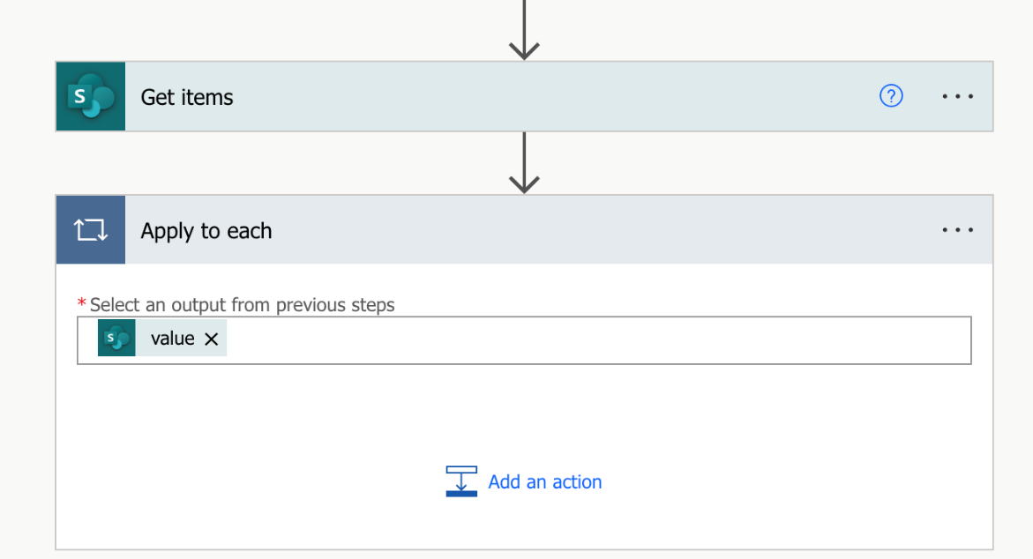

e. Click on **Add an Action** and select **Get Item** control for the SharePoint connector

* Site Address: <SharePoint Site URL>
* List Name: Work progress tracker
* Id: ID (from the Get Items action)

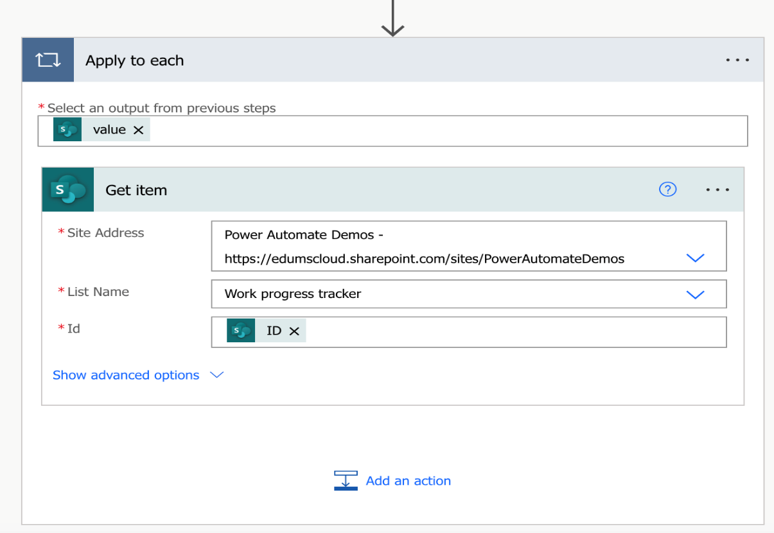

f. Add a **Condition** control and check for the below conditions:

* if **Progress Value** is **not equal to** **Completed**
* if **Due Date** **is less than** **utcNow()**

Please note that we have used an expression to compare the due date as this value is not available in the flow

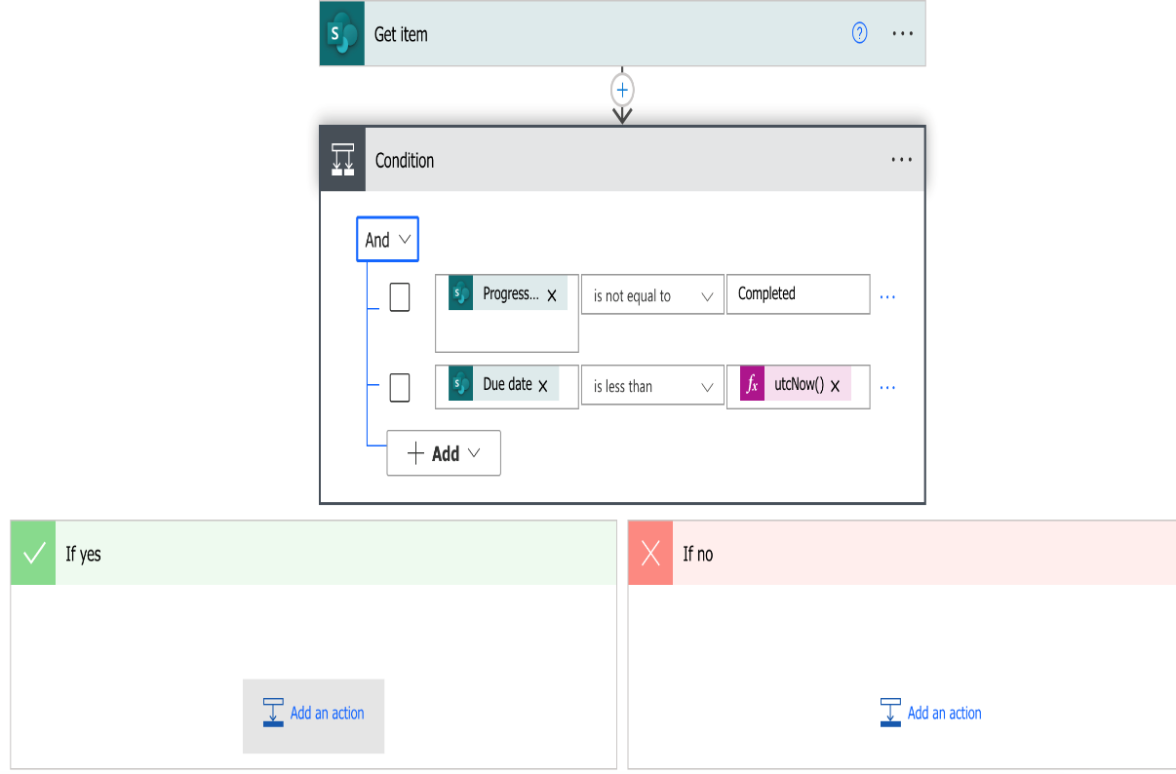

g. Add an action under the **If Yes** branch:

* Select **Send an email(v2)** action
* To: **Assigned to Email** from the dynamic content
* Subject: Your task is late!
* Body: **Title** from the dynamic content

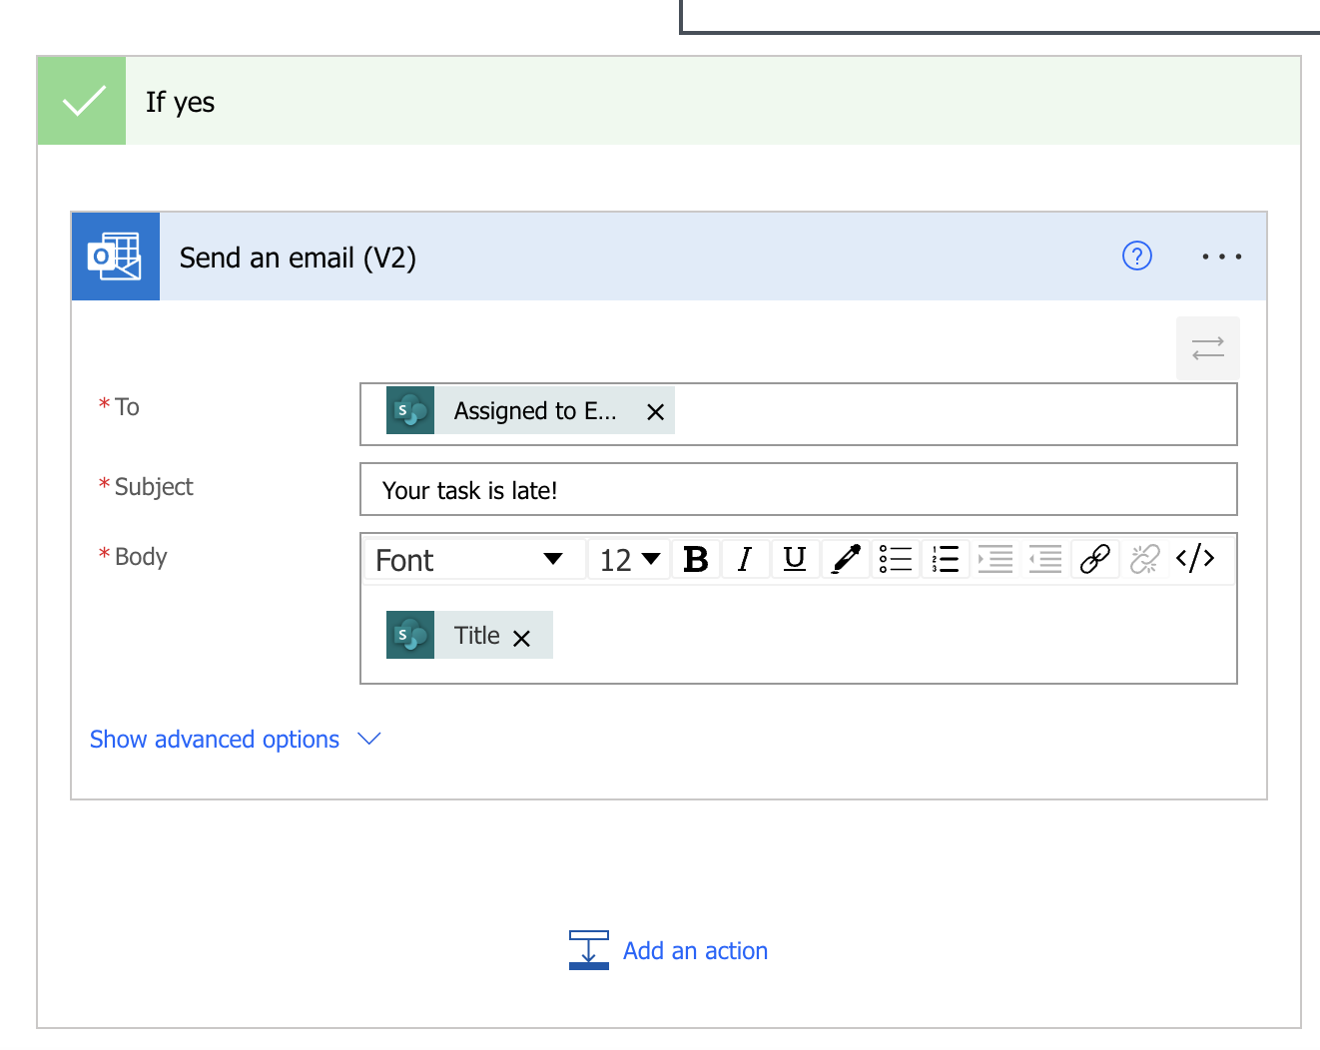

h. **Save** the flow.

**Task 2**

To test the flow, trigger it manually. Click on **Run** > **Continue** > **Run Flow** > **Done**. This will send an email for all the tasks which are overdue.

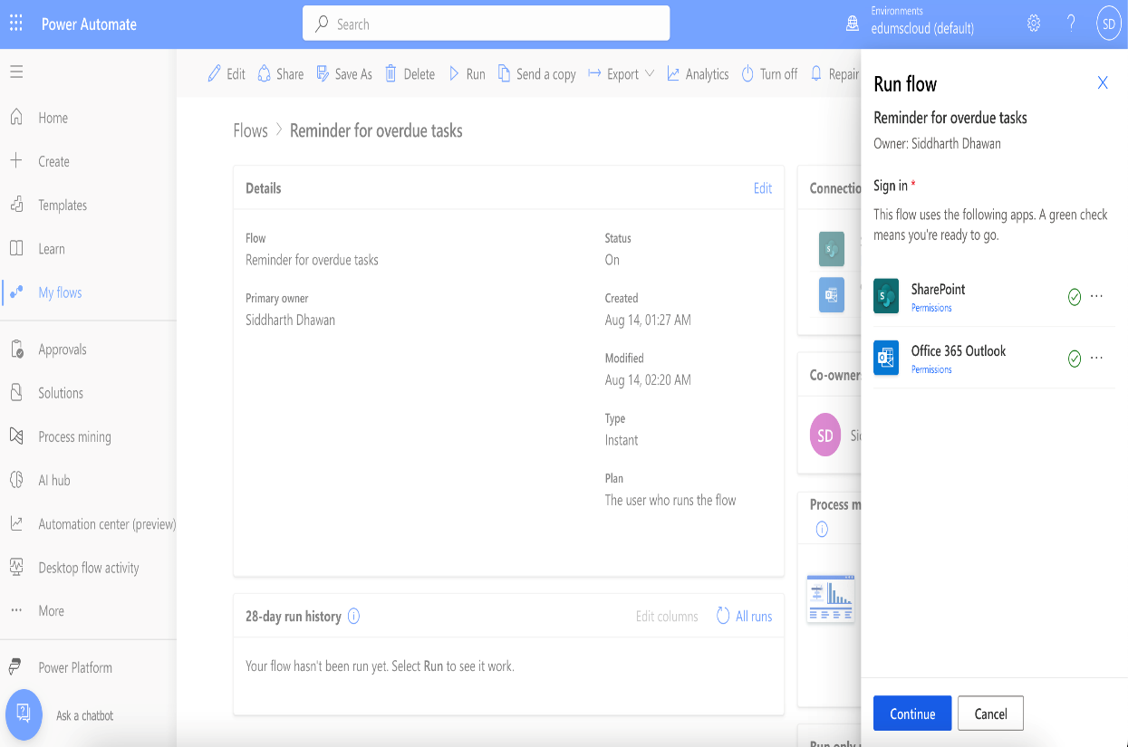

Verify the email.

